PMLD Network response to
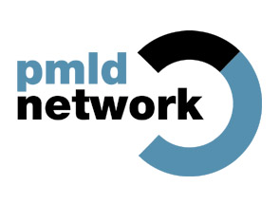
Valuing People Now

Introduction

The PMLD Network is a group of organisations who are working together to fight for the rights of children and adults with profound and multiple learning disabilities (PMLD). The Network believes that focusing on the needs of these individuals, who face double discrimination, should be a priority. The needs and rights of people with PMLD are frequently neglected. They remain some of the most disadvantaged people within our society. If this is going to change then it is vital that there is a much better understanding of the distinctive needs of these people who are so often excluded.

The vision set out in Valuing People and the subsequent programme of action and new initiatives have largely failed to impact on the lives of people with PMLD. If we are going to ‘include everyone’ this needs to be a top priority in this next phase of implementing Valuing People.

The PMLD Network believes that everyone has a right to be included in society. But this will not be achieved by a ‘one size fits all’ approach. Real progress will require an understanding that sometimes there will be a need to provide additional things to achieve the same outcome: an ordinary life. As Valuing People states, the ‘role of public services is to help people, no matter how complex their disability to live full and equal lives in their local communities’.

This submission sets out the main issues that need to be tackled within Valuing People Now so that people with profound and multiple learning disabilities can take up their rightful place in society.

The PMLD Network has consulted on this submission via the network email forum and focus groups.

Who are people with profound and multiple learning disabilities (PMLD)?

The PMLD Network has developed the following definition:

Children and adults with profound and multiple learning disabilities have more than one disability, the most significant of which is a profound learning disability. All people who have profound and multiple learning disabilities will have great difficulty communicating. Many people will have additional sensory or physical disabilities, complex health needs or mental health difficulties. The combination of these needs and/or the lack of the right support may also affect behaviour. Some other people, such as those with autism and Down’s syndrome, may also have profound and multiple learning disabilities.

All children and adults with profound and multiple learning disabilities will need high levels of support with most aspects of daily life.

Appendix 2 provides more information on what it means to have a profound and multiple learning disabilities and the accompanying CD Rom ‘Meet the people’ contains video clips which focus on the lives of six people with profound and multiple learning disabilities.

Including Everyone

What we want

If Valuing People Now is going to work for everyone:

- There needs to be a much better understanding of the numbers and needs of people with a learning disability, particularly people with profound and multiple learning disabilities (PMLD), to ensure proper planning and monitoring of the support they receive.

- New initiatives which have the power to transform lives must work for people with the most complex needs, for example people with profound and multiple learning disabilities (PMLD).

- There needs to be a particular emphasis on the associated health needs of people with PMLD and the development of standards and performance management of NHS services relating to this population.

Main response

The PMLD Network welcomes the greater emphasis that Valuing People Now places on the needs of people with complex needs. In particular that:

- The government recognises that people with the most complex support needs have been missing out on the changes brought in since Valuing People.

- It says that when planning and delivering services you should start by thinking about those with the most complex needs.

- It says that you should think about what additional services and supports are needed for people with the most complex needs rather than developing separate services. This is so that people with the most complex needs can be included with everyone else.

In the view of the PMLD Network, these are sound principles and they recognise that much needs to be done to ensure the inclusion of people with profound and multiple learning disabilities (PMLD). In a recent study conducted by ‘Inclusion Europe’ (to be published), looking at the discrimination faced by people with severe and complex disabilities across 12 European countries, it concluded that the greater the progress towards mainstream services, the higher the risk of exclusion and segregation. This study is a stark warning of what will happen if we do not focus on the needs of this population.
In order to ensure that the vision set out in Valuing People Now is actually realised for everyone - including those with the most complex needs - there are a number of important actions that must be taken.
In this part of the submission we will focus on what we view as the two main reasons why people with profound and multiple learning disabilities (PMLD) – who have the most complex needs – have been missing out on the Valuing People agenda. We will go on to give examples of actions that must be taken to ensure that this does not continue to happen.
Valuing People Now says that the government recognises that people with the most complex support needs have been missing out on the changes brought in since Valuing People

In the PMLD Network’s view there are two main reasons why people with profound and multiple learning disabilities (PMLD) have been missing out:

1. There is a serious lack of understanding of the numbers and needs of people with PMLD. This has resulted in poor planning and monitoring of the support they receive:

‘If we don’t know about the population of children with PMLD, how can we possibly plan for their future and get it right? We urgently need to address the needs of children and adults with PMLD’ - Health professional (PMLD Network survey 2006)

Research has shown:

- A lack of recognition that people with PMLD are a group of people who might have specific needs requiring specialised support.

- The lack of accurate information and consistency in definitions of need make longer term service planning and development difficult.

- The numbers of children with PMLD are continuing to increase because more premature babies are surviving, medical science is prolonging lives that would have been lost in infancy and people with PMLD are living longer.

- We have a new younger generation of people who are dependent on medical technology and have complex and continuing health care needs.

There is very little data on the population of people with PMLD. However what there is, demonstrates a rise in the numbers of people with PMLD and the fact that their needs are becoming more complex. For example:

The Sheffield Care Trust (2006) – summary of findings from Adult Learning Disability Day Services PMLD sub group and additional Case Register information found that:

The number of 10-14 year olds with PMLD has increased by 75% in the last 5 years, including an even higher number of children with PMLD who will need services as adults in 5 to 10 years time’

2. People with profound and multiple learning disabilities (PMLD) are not represented by partnership boards, or by regional or national forums

The PMLD Network welcomes the work that Valuing People has achieved in supporting and listening self-advocates. However, there has been no real progress in involving people with PMLD in a meaningful way resulting in the fact that their needs are not considered.

The Valuing People Support Team developed an inclusion checklist for people with high individual support needs for Partnership Boards to use in 2004. It asked Partnership Boards to find a champion, understand more about people’s needs and to check that all the plans produced by Partnership Boards work for people with high support needs. This was a good piece of work but there does not appear to have been any monitoring of its implementation or outcomes.

There are now many creative techniques being developed to meaningfully consult and involve people with profound and multiple learning disabilities. They include the work being done by Mencap’s ‘Getting to Know You’ project, which support self-advocates to communicate with people who do not use formal means of communication and to understand the issues that they need to speak out on, on their behalf. One example of a campaign which many self-advocates have achieved success with is ‘Changing Places’ which calls for toilets with a bench, hoist and plenty of space – facilities needed by people with PMLD – to be installed in all big public places.

The Doncaster Advocacy service has helped people with PMLD represent themselves using multi media techniques. Personal DVDs were produced with a number of individuals who will participate in the partnership board, with support from their advocate, to increase understanding of the important issues in their lives.

Good representation is both possible and achievable.

Valuing people Now says that ‘when planning and delivering services you should start by thinking about those with the most complex needs’

We welcome the recommendation to think about those with the most complex needs first. But it must happen in practice. For example if personalisation is going to work for everyone, the government needs to make serious commitments to meeting the specific needs of people with profound and multiple learning disabilities (PMLD).

The personalisation agenda has the potential to transform the lives of people with PMLD. The very complexity of their needs means that individually designed support can greatly enhance their quality of life. However, the move towards individual budgets has so far demonstrated a limited number of examples of individual budgets being implemented for these people. Priority should now be given to offering individual budgets to people with PMLD.

To implement individual budgets for people with PMLD:

- The resource allocation process should recognise the true costs of support.

- There should be no upper limit on support packages.

- There needs to be recognition that the complex needs of these individuals often require complex support packages and that these packages often include health care provision.

- It must be possible for people who are un-befriended or who do not have strong family support to have the same opportunity to have an individual budget.

For more information please read the section on personalisation.

Valuing People Now says that you should think about what additional services and supports are needed for people with the most complex needs rather than developing separate services. This is so that people with the most complex needs can be included with everyone else

The PMLD Network supports this view and would like to give two examples of additional support people with PMLD need:

1. A skilled and sustainable workforce
All people with a learning disability need access to good support wherever they live, work or to access leisure opportunities. Staff who support people with PMLD need additional skills. They need to have a full understanding of the complex health needs, be able to communicate with people who may not use formal means of communication and sometimes be able to support people whose behaviour challenges services. We are concerned that the lack of availability of a suitably skilled workforce and the fact that local authorities often refuse to pay for skilled staff support are major barriers to the inclusion for many people with PMLD.

2. Additional health support
The PMLD Network agrees that people with profound and multiple learning disabilities should be able to access mainstream services as much as possible. However, there remains a need to access specialist skills where they are needed. One example of this is access to postural care. For people moving in to adult services there is a shocking decline in access to all physical therapy services, such as physiotherapy and hydrotherapy and this is combined with poor equipment provision. The resulting deterioration and distortion in body shape and posture is reducing the life expectancy of people with PMLD. Whilst less immediate than the cases that Mencap reported in the ‘Death by indifference’ report, this neglect is leading to premature death. For more information please read the section on health and visit www.posturalcareskills.com

Diversity

In many ways the arguments put forward in this submission, which has focussed on the needs of people with PMLD, could equally apply to people from BME communities: the need for better data, planning and monitoring and the need to ensure good representation at a local and national level.

A key piece of research by Hester Adrian (Azmi et al 1996) projected that between 2001 and 2021 that 1 in 10 people with a learning disability might belong to a BME community. It also found that between the ages of 5 and 34 years of age, the prevalence of people with severe learning disabilities was approximately three times higher in the Asian communities.

More recently the report from the Sheffield Care Trust (2006) found that people with a learning disability from BME communities have a higher incidence of severe and complex needs:37.5% of those with PMLD aged 14-19 are from BME communities.

Mencap’s Reaching Out research highlighted that many families from black and minority ethnic groups are not receiving services that meet their cultural needs so many are not engaging with services at all. If we are to ensure inclusion, we need to focus on the issues that will ensure people with a learning disability and families from BME communities can access services and support.

Making it happen

To include everyone we need to:

- Make ‘Including Everyone’ a top priority.

- Know more about the numbers and needs of people with profound and multiple learning disabilities (PMLD).

- Check that people with PMLD have equal access to all forms of support to have ‘an ordinary life’.

- Fully understand the cost of the support that will be needed to achieve this.

Personalisation

What we want

- The government needs to ensure that individual budgets include everyone. This means understanding the true cost of the support needs of people with profound and multiple learning disabilities (PMLD).

- People with profound and multiple learning disabilities (PMLD) should be given priority for person centred planning. Staff should be properly trained in engaging with people so that people with PMLD are involved meaningfully in their development.

- For people with PMLD support needs to be bespoke, competent and long term. The quality of relationships in people’s lives is a critical factor.

Main response

The PMLD Network welcomes the government’s commitment to choice and control for all people with a learning disability. Individualised support has the potential to transform the lives of people with profound and multiple learning disabilities (PMLD). But there are many concerns about how this will be implemented for people with PMLD. These concerns are illustrated by the response to the PMLD Network survey in 2006:

‘Direct payments and Individual Budgets are causing more stress for carers – we don’t want them’ – Parent

‘Individual budgets - What about the very large number of people who don’t have supportive, knowledgeable family carers?’ – Day services manager

‘All support is based on cost not personal need’ – Finance manager

‘Individual budgets are being ‘marketed’ to SSD staff/ managers on the basis that Individual budgets can actually ‘save costs’!’ – Advocate

The government must be committed to meeting the true costs of support packages for those with the most complex needs. The Network is aware that some families are in dispute over the Resource Allocation stage because of the cost of staff support. It is often the case that basic support staff are not skilled enough to meet people’s needs, especially when they have complex health or behaviour needs. No one should be seen as too disabled, too difficult and too expensive to have equal access to individual budgets.

Person Centred Plans (PCP)
The PMLD Network survey showed that only half of the respondents said that the person with PMLD they support had a PCP and only half of these respondents said that the person with PMLD had been meaningfully involved in developing their PCP. The main reason for this was that most staff are not trained in ways of engaging with people with PMLD in their PCP.

‘We need a better a quality audit for PCP’ – Day services manager
‘Plans don’t necessarily change thinking’ – Day services manager
‘Need to invest in how people support the delivery of plans’ – Day services manager

Making it happen

Individual budgets:

- There should be no artificial top limit for individual budgets.

- The resource allocation process should recognise the true costs of support.

- There needs to be recognition that the complex needs of these individuals often require complex support packages.

- It must be possible for people who are un-befriended or who do not have strong family support to have the same opportunity to have an individual budget.

- The government needs to gather data about the highest level support packages for people with the most complex needs.

- The government should explore the idea of providing central government funding to enable realistic support packages for people needing high levels of support.

Person centred planning:

- Plans for individual budgets should be based on good person-centred planning and the involvement of a circle of support.

- Staff must have the training and skills needed to involve people with profound and multiple learning disabilities (PMLD) in meaningful PCPs.

- Person centred plans need to be part of inspection criteria for services, with sporadic checks that plans are being implemented and that they demonstrate the meaningful involvement of people with PMLD.

- People with profound and multiple learning disabilities (PMLD) should be given priority for person centred planning

What People Do During the Day (And Evening And Weekends)

What we want

- People with profound and multiple learning disabilities (PMLD) need meaningful activities. The focus shouldn’t just be for local authorities to get people with a learning disability into work as this may not be appropriate for everybody.

- Day services should not close unless there are robust alternatives in place.

- Services must address the resource issues, staff skills and the practical challenges of meeting diverse needs in an imaginative way.

- Day services programme should be planned, monitored and evaluated with the needs of people with PMLD in mind.

Main response

The PMLD Network believes that in order for the principles in Valuing People Now to be realised for all, attention must be paid to the specific needs of people with profound and multiple learning disabilities (PMLD) and their need to have meaningful day time activities respected. The modernisation of day services programme has not always properly considered the needs of people with profound and multiple learning disabilities (PMLD), such as the staff support needed for someone who requires 2:1 support for their moving and handling needs, how complex health needs e.g. PEG feeding can be met within a community setting or the special transport needs of someone who may not use a standard wheelchair, this has resulted in people receiving less day time support than before. This is not acceptable.

Over emphasis on work
There is an over emphasis on work which is not realistic for the majority of people with profound and multiple learning disabilities (PMLD).

‘that the emphasis should change from Day Services to people with PMLD getting PAID jobs is unbelievable’ – Parent

We need to be realistic. The current situation, as evidenced in a scoping study commissioned by CSCI, is that ‘none of the people within PMLD sample was in paid employment and that most- 59%- attended a day centre’ CSCI – People with PMLD -scoping study

When day services close and there are not appropriate alternatives in place, the result is that many people with PMLD are forgotten and remain at home with nothing to do. As well as the fact that this denies them the opportunity to learn, develop and have a fulfilling life, this also has a major impact on the lives of their families. These families already face massive caring responsibilities and need more, not less support (see section on families).

College places have been cut
Other opportunities for meaningful activities are college courses which have been held up as the alternative to day centres. But they are also being cut, especially for people with profound and multiple learning disabilities. The London West Learning Skills Council (LWLSC) mapping and service needs for those with ASD or PMLD, Research for Tomorrow, Today (2003) identified the fact that many sources of funding and course design are either not appropriate, are too short term or too work focused for this group and that new provision and guidelines will need to be amended to allow for this.

Whilst their achievements may be measured in much smaller steps, people with profound and multiple learning disabilities (PMLD) continue to learn and develop all their lives. There needs to be a redefinition of learning to include a wider range of non academic services, outcomes and funding criteria so that people with PMLD can access appropriate FE opportunities.

The need for creative inclusion- with some buildings bases
People with profound and multiple learning disabilities (PMLD) have the right to access community based activities like everyone else. However this needs to be a meaningful experience and balanced with an understanding that there are times when people will need an appropriately designed base at which to meet their needs. This is not an argument for segregation but for a more imaginative and creative approach to inclusion. Building bases can service a wide number of citizens: the hydrotherapy pool that includes a local mother and baby group and one for the elderly. The sensory room that provides for people with mental health issues as well as young children. Well located and designed facilities such as these can bring the community in and build relationships.

Real inclusion also means good staff training in how to use the community in an imaginative way, for example the local music project that includes people with profound and multiple learning disabilities (PMLD) to make and record their own music.

Real inclusion recognises that some people need specialist support to meet their needs such as communication and complex health needs, specialist facilities such as Changing Places toilets in the community and more accessible transport:

‘’Full on inclusion’ tends to lead to people being more marginalised and isolated (with exceptions) because they have not been enabled to have the necessary life skills to cope in an open environment. If you complain about closure of services with no replacements or alternatives you are ‘labelled’ as being against ‘independence’ - PMLD Network forum

‘We need bases, local bases that the Council can be proud of’ - Parent

‘The idea of closing day centres is extremely worrying for those family carers who rely on the day centre support’ - Parent

‘Little thought has gone into the practical aspects of the changes – it is theory gone mad’ - Parent

‘Where will people go if there are no specialist facilities’ – Parent

Making it happen

Meaningful day time activities are ones that are:

- Stimulating and meaningful to the individual.

- Support people’s physical and health needs in a dignified manner.

- Access the community by taking part in activities that the person finds genuinely enjoyable.

- Recognise that many people with PMLD experience the world largely on sensory level and develop activities that take into account.

- Include people in community activities in a way that is meaningful to each person.

- Provides community resource bases equipped for meeting complex physical and health needs.

- Ensure that manual handling policy and practice don’t act as a barrier to taking part in community activities.

- Invests in a workforce that is both sufficient and skilled to meet complex health needs and non-formal communication techniques.

- Provide suitable and flexible transport that enables people to physically move around their community.

Better Health

What we want

- A workforce that can support people with complex health needs wherever they receive their support.

- NHS Commissioning that recognises the need for access to specialist expertise.

- Annual health checks, Health Action plans and health facilitation in place for all people with profound and multiple learning disabilities (PMLD).

- Release of ‘health care finance’ into bespoke packages of support.

Main response

The PMLD Network welcomes the emphasis Valuing People Now places on better health. This is a vital area for people with profound and multiple learning disabilities (PMLD) who may have a wide range of health needs, such as complex epilepsy. It is known that an increasing number of people are technology dependent, which can mean they need oxygen, tube feeding or suctioning equipment. It is also known that there are an increasing number of children and young people who have even more complex needs, such as being reliant on more that one type of technology.

However, access to both mainstream health care and high quality specialist health care is poor. Many health professionals are ill equipped to meet the needs of people with profound and multiple learning disabilities (PMLD). Sometimes this can mean that people with PMLD can be left with undiagnosed conditions, such as impacted ear wax that directly affect their quality of life. However at it most serious we know that many families and care staff report that health professionals hold negative assumptions and beliefs about the quality of life of individuals. Ultimately this can lead to the denial of treatment as starkly illustrated by Mencap’s ‘Death by indifference’ report.

‘People only get regular health checks and health action plans at the insistence of care home staff’ - Service manager

‘Less than ½ the respondents said that the people with PMLD they support have regular, comprehensive health checks
PMLD Network questionnaire 2006

Transition from paediatric to adult services can be very problematic and providing good quality health care for people in transition requires adequate resources - Specialist nurse for learning disabilities’

The importance of postural care
Many people with profound and multiple learning disabilities have physical disabilities and need access to physiotherapy, hydrotherapy and postural care. There is growing concern that adults who may have had regular access to these during childhood have limited support once leaving school. This can result in deteriorating body posture and in some case, premature death.

Tommy’s story
Tommy lives in a community home in Perth, Western Australia. Tommy used to sleep in a very destructive position which was causing him lots of problems. At the age of 40 Tommy could not digest food easily, he was in a lot of pain and his capacity to breathe was being hindered by his positioning. The images below show Tommy’s sleeping position, how this translated into his sitting position and how he demonstrated that he was in pain.
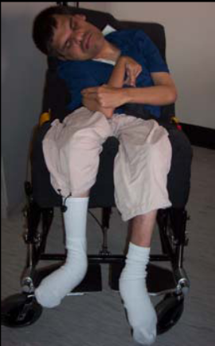
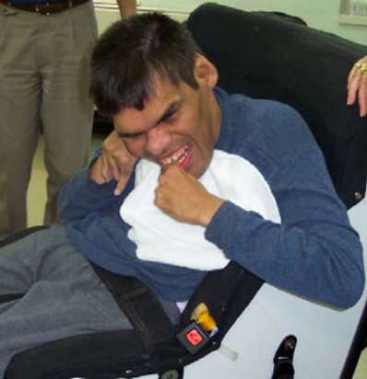
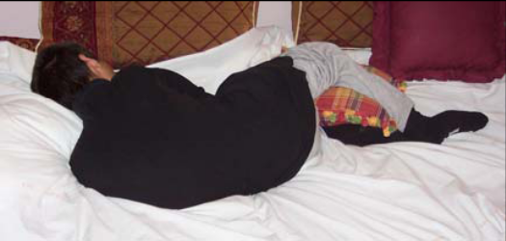

Over a two year period, Tommy’s sleeping position was very gently altered by his hard working Personal Assistants. They slowly brought him on to his back, safely, and de-rotated his chest. As you can see from the images below this had a huge impact on Tommy’s quality of life. At 42 years of age Tommy is no longer in pain and he is much more comfortable. With the right skills and knowledge we can successfully restore body shape even into adulthood as we can see through Tommy’s story.
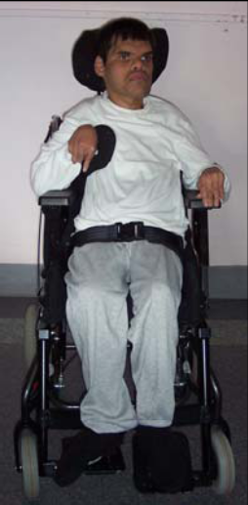
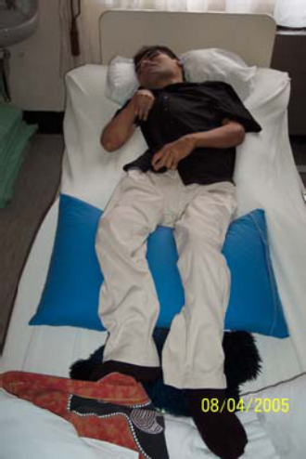
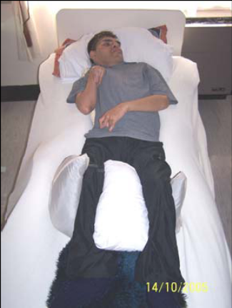
Text and images are Copyright ©PCSP – Postural Care Skills Programme (UK) Ltd 2008

The need for a holistic approach
People with profound and multiple learning disabilities (PMLD) rely on a wide range of health support. Dentistry, ophthalmology and audiology are each vitally important to health, wellbeing and independence. But we know that people struggle to access these services. For example, Optometrists are not given enough extra money to test people with PMLD and so their needs are often not picked up. This affects people’s quality of life.

Individuals with PMLD often experience more than one health condition, such as complex epilepsy and respiratory problems. They are often prescribed a range of medication. It is important that they have the opportunity for a regular review of these needs by a specialist team with the skills to understand the interaction between the various conditions and the treatment they are receiving.

Making it happen

Good health support for people with PMLD includes:

- Investment in the growth of local health specialists to meet the needs of the increasing numbers of people with complex health needs.

- Annual health checks with the person’s GP and wider primary healthcare teams (these should be thorough and personalised in terms of the person’s complex health needs).

- Annual checks of vision and hearing.

- Regular dental checks.

- Health Action Plans in place and regularly reviewed.

- Training for health professionals to challenge negative assumptions and beliefs about the quality of life of individuals with PMLD.

- Training for all NHS Staff about the particular needs of people with PMLD, with a focus on communication.

- Training for all social care staff on supporting people with complex health needs.

Improving People’s Housing Situation

What we want

- People with profound and multiple learning disabilities (PMLD) should have choice and control about where they live.

- Support staff should be trained to meet complex needs so that lack of skilled support does not mean that people cannot choose where they want to live.

- More funding for high quality, safe and fully supported housing to be provided for all adults with PMLD.

Main response

The PMLD Network welcomes the emphasis that everyone should have a home of their own. But there needs to be recognition that the support needed to do so will often be both complex and costly for people with profound and multiple learning disabilities (PMLD).

Currently most people with PMLD stay at home well into adulthood and many parents feel there are very limited alternatives that are able to meet the needs of their son/ daughter. Offered no suitable alternative, many families struggle on for as long as they can. When parents become ill or die, there is a risk that local authorities make hasty and ad hoc decisions about where people with PMLD will be placed. Such placements are in very short supply and so some people will end up in inappropriate services, or far from the home community and will most likely be living in traditional forms of residential care.

Too often, choice about where someone may live is linked to the shortage of staff with the right skills. Families tells us what happens when these skills are not available, how the health and well being of their family member has been jeopardised by poor care, such as not being able to give someone a drink properly, allowing pressure sores to develop and even not administering epilepsy medication regularly.

The right to have a home of one's own, to be able to live independently, is one that most adults take for granted – but it is not available to most adults with PMLD. For most young people, a vital element of growing up involves loosening parental ties and leaving home - for young people with PMLD this stage in their development may never take place. This must change.

There needs to be real choice over where and with whom people with PMLD may live. People with PMLD are nearly always placed with others with PMLD. However opportunities should be explored for example there have been some instances of people with PMLD sharing with more able people with a learning disability that have been mutually beneficial. There are a few really good examples of the lives that people with profound and multiple learning disabilities could achieve when funding and skilled support is in place. However, the majority of these examples have been hard won and harder still to keep in place.

Victoria’s story

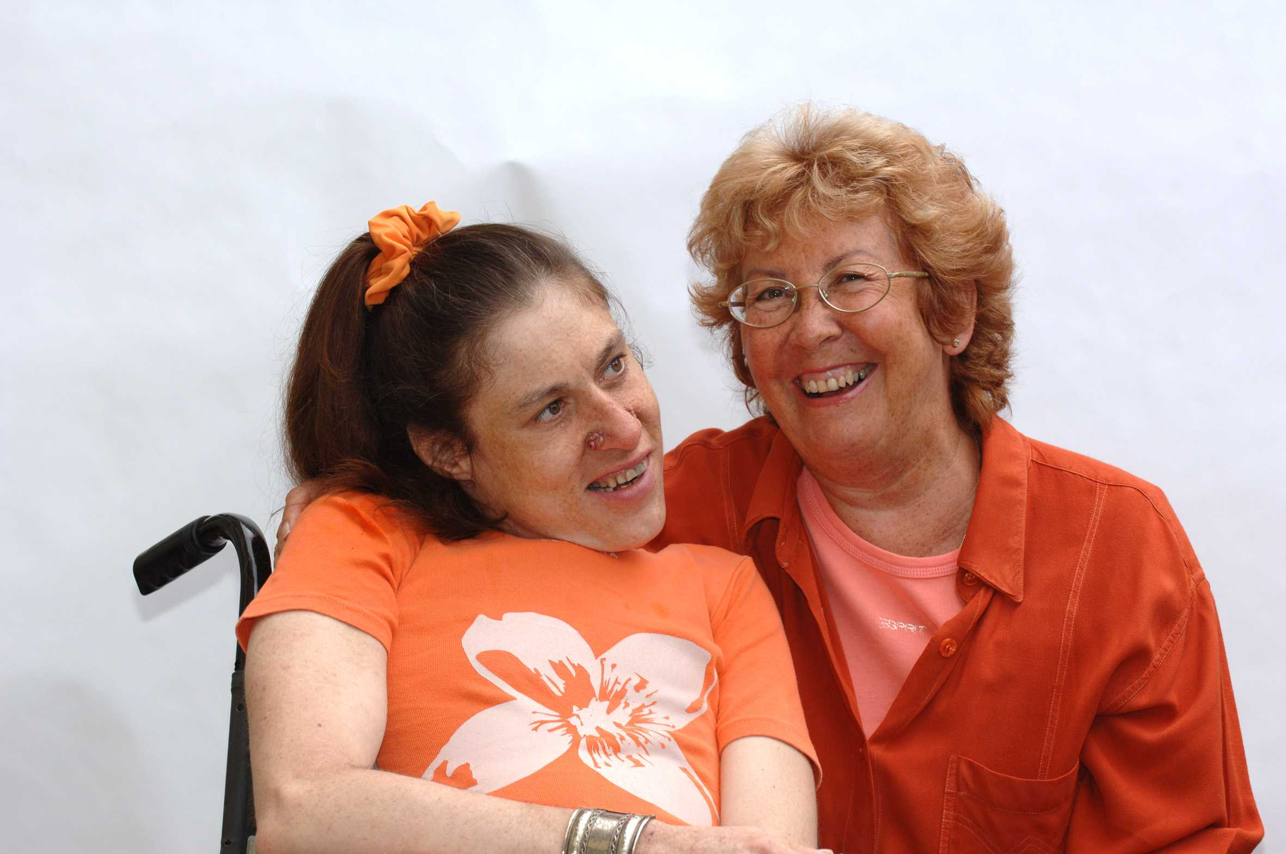

Victoria (pictured above, left, with her mother Jean) lives in her own tenancy in the London borough of Islington. She has 24 hour support, a circle of friends and a person centred plan and very much lives the life of her choice. Her mother Jean has had to consistently fight to keep this in place. Islington have now, made the decision that they will never again fund individuals with complex needs to live independently because the costs are too high.

Making it happen

To ensure that people with profound and multiple learning disabilities (PMLD) have the same housing opportunities as others there needs to be:

- A skilled workforce that can support people who have complex health, behaviour or communication support needs wherever they live.

- More funding for high quality, safe and supported living opportunities.

- A range of choices from registered care to supported living.

Advocacy and Rights

What we want

- We want greater advocacy provision for all people with profound and multiple learning disabilities (PMLD) who have the greatest need for it.

- We want greater user representation and involvement in policy-making for people with PMLD whose needs are often neglected.

Main response

Lack of representation on partnership boards and in self-advocacy groups
The PMLD Network welcomes Valuing People Now’s promise to increase investment in the full range of advocacy provision as advocacy does much to ensure that the voices of people with a learning disability are heard.

‘I don’t think the needs, wishes and ambitions of people with multiple disabilities have been considered adequately in the planning of services. Our local partnership board have never discussed the needs of this group of people’ - Director of a service for adults with a learning disability

We welcome the focus on developing the body of self-advocates operating at a national and regional level. However we are concerned that unless mechanisms and monitoring is in place to ensure that the needs of people with PMLD are represented in these groups, their needs will continue to be ignored at a national and local level. Likewise, partnership boards, the Learning Disability Task Force and other groups involved in policy-making must ensure that they have mechanisms in place to ensure the needs of people with PMLD are represented.

An example of a project aiming to support people with profound and multiple learning disabilities (PMLD) to speak up is “Getting to Know You” (photo below). This is a Mencap pilot project which offers an introductory training to self advocates with learning disabilities in including and speaking up for the needs of people who do not use any formal communication system. Self advocacy projects around the country are requesting this training for their members as people with PMLD are so excluded from this type of work. Peer advocacy relationships are being built up and the issue of exclusion from decision making is being approached. This work is also very empowering for people with learning disabilities who do use words and speak up for themselves as their skills and experience are so valued.

Advocates for people with PMLD
‘A way forward to improve the lives of people with complex support needs is to involve independent advocates in the PCP process or any major life decision making.’ - Support worker

Most people with profound and multiple learning disabilities (PMLD) will not use formal communication and yet are largely surrounded by a workforce that is not trained to understand their communication method. They are most in need of someone to ‘speak up’ for them and yet there are few advocacy schemes which can support them. There appears to have been little increase since the Advocating for Equality report (2004) showed that only 11% of advocacy schemes could support someone with PMLD. Most advocates are still not trained in non-formal communication methods which are needed for non-instructed advocacy. The numbers of people with PMLD are increasing so robust advocacy provision for them is more essential than ever:

John’s story
John is a young man with profound and multiple learning disabilities (PMLD). When his family, who lacked support, felt they could no longer care for him, he moved into a group home.

The staff at John’s new home struggled to understand his communication and what he wanted. Frustrated and confused, John’s behaviour got worse. Soon John was admitted to a psychiatric unit (a hospital for people with mental health problems).

Eventually John got an advocate who understood how to work with him. The advocate spent time with him, got to know him and worked with those who knew him best to find out how he communicated. The advocate supported relationships to be slowly built between John and the staff at his residential home.

If John had had an advocate sooner he might never have had to go to the psychiatric unit which was both inappropriate and distressing.

The PMLD Network believes that every person with profound and multiple learning disabilities should have access to an appropriately skilled advocate (trained in non-formal communication methods). We must increase advocacy provision for people with PMLD

Mental Capacity Act
The PMLD Network welcomes the introduction of the Mental Capacity Act which puts into law the rights of people who lack capacity to make their own decisions, as well as those who can make their own decisions. If used properly, the Mental Capacity Act is a useful tool which can be used to empower people with a learning disability to make their own decisions where possible; help people to make a decision in the best interests of someone with a learning disability, if the person lacks capacity to make that decision themselves; make sure that people with a learning disability do get the medical treatment they need even if they are unable to consent to it.

We are concerned, however, that despite guidelines in the Code of Practice - instructing that a person trying to work out the best interests of a person who lacks capacity should not make assumptions about the person’s quality of life - decision makers are making assumptions about quality of life or using information to make best interests decisions which is not free from discriminatory assumptions. This can have serious consequences.

Some people may not be aware that they hold negative assumptions about the quality of life of people with a learning disability. Unless people receive training which increases their understanding of what it means to have a learning disability, people will continue to not value people with a learning disability and neglect their needs and rights. Discriminatory assumptions about the quality of life of people with a learning disability, particularly those with PMLD, is widespread and needs to be challenged.

We welcome that under the Mental Capacity Act, an Independent Mental Capacity Advocate (IMCA) must be instructed for ‘unbefriended’ people who lack capacity to make certain important decisions. However we remain concerned that ‘befriended’ people with a learning disability who lack capacity to make these decisions are left without advocacy provision. We would like best practice guidelines about involving independent advocates when someone lacks capacity to make these decisions but is ‘befriended’.

We would like all people with a learning disability - regardless of whether or not they are ‘unbefriended’ - to have the opportunity to involve an independent advocate in other important decisions about their lives, for example decisions around person-centred planning and how to spend individual budgets. We would like there to be best practice guidelines about involving independent advocates in such decisions for people with PMLD who lack capacity to make these decisions themselves. This would help ensure that the person’s best interests are safe-guarded.

Conclusions from the Joint Committee on Human Rights inquiry back up these recommendations: ‘we are persuaded that for may many people with learning disabilities access to independent advocacy may be the only realistic means of securing their human rights’ and ‘we consider that adults with learning disabilities, particularly those who are most vulnerable (including adults with complex and profound learning disabilities) would benefit greatly from the assistance of independent advocates in order to secure their human rights’.

Making it happen

There needs to be:

- Increased investment in non-instructed advocacy.

- More advocates trained in non-formal communication techniques which will enable them to be able to practise as non-instructed advocates.

- An opportunity to involve independent advocates in all important decisions affecting someone with PMLD’s life eg. decisions around person centred planning and how individual budgets will be spent.

- Best practice guidelines will make sure that best interests decisions are free from judgements about quality of life.

- There will be a PMLD champion in self-advocacy groups and other groups involved in policy-making. These groups will have a policy on how they creatively consult with people with PMLD.

- Funding for projects/ pilots to look at creative ways of involving people with PMLD.

Partnership with Families

What we want

- The importance of family carers to be recognised.

- Families to get the support they need, including a minimum entitlement to good quality short breaks.

Main response

The PMLD Network welcomes a greater emphasis on partnership with families. Families of people with profound and multiple learning disabilities (PMLD) often face a life time of caring. They fulfil a huge number of roles: family, carers, and campaigners – as many have to fight on a daily basis to get the services that the person needs. They do all this because they love them but they do need much more support.

Short breaks respite services
‘We need and want short breaks/ residential services in our community’ - Parent

‘We need greater respite – not everyone is getting a break’ – Parent

In 2001 Mencap reported that 60% of parents of children and adults with profound and multiple learning disabilities (PMLD) spent more than ten hours per day on basic physical care. One third of these had a continuous caring role of 24 hours per day. 78% of families received either no support at all or less than 2 hours per week. Unsurprisingly, few families were satisfied with the care support services they were receiving. Very little has changed for families since then. This is illustrated by the second Breaking Point report (2006) in which Mencap reported that 7 out of 10 families have reached or come close to breaking point because of a lack of short break services. 5 out of 10 families who have had a carer’s assessment got no services as a result. 1 in 3 families had experienced a cut in their short break services in the last year.

It is in this context that many families hold the view that far from things improving for them since Valuing People, some things have actually got worse. For example whereas before you might not have been getting a short break service, now, in addition there may be no day centre for your son/daughter to attend or you may have found that the college placement you were relying on as the next stage for your son/daughter after school is no longer possible as they have cut suitable courses.

We want there to be a minimum short breaks entitlement for families. The short breaks must be of good quality. This means they must meet the needs of individuals and their families.

We are delighted that the government has responded to lobbying and created a new duty on local authorities to provide short breaks to support families with disabled children. We want this to be followed by a duty on local authorities to provide short breaks to support families of adults with profound and multiple learning disabilities (PMLD) – as for many families caring does not stop at the end of their son/daughter’s childhood – it is a lifelong commitment.

Listening to family carers
Families and carers are a key ‘human resource’ to be informed, consulted and supported in all the issues addressed in Valuing People Now, including those around Personalisation, What people do during the day, Health, Housing, Making change happen.

Families are not hanging on to traditional services for the sake of it. They are hanging on to the services that work. Many are fearful of new initiatives when no one has taken their views in to account about how things could work for someone with the complex needs their son/daughter may have. New initiatives also place new demands. Direct payments and individual budgets require high levels of involvement for families.

‘We wanted to retire, not manage a staff team of six and learn how to do the accounts!’-Parent

For others some new initiatives sound fantastic in principle but they just don’t have the energy and fight left to give them a go:

‘Direct payments seem like beacons in the fog. If only we could reach them’.- Parent

Families need information and support to guide them through the process. But most of all they need to be listened to and never more so than when their son/daughter has profound and multiple learning disabilities (PMLD). They know in great detail what will work and what will not. There needs to be a new spirit of partnership between families and professionals. An example of partnership at the individual level might be for the parents’ knowledge of their son or daughter – perhaps written in the form of a ‘life book’ which details information about their son/daughter’s history and family - to be recognised and valued by professionals as the basis to start person centred planning from.

Families and carers have huge experience and commitment to contribute to partnership in planning –locally on Partnership Boards and Local Strategic Partnerships; nationally on the Standing Commission on Carers. This needs to be recognised, valued and facilitated.

Making it happen

- The importance of family carers needs to be recognised and their participation facilitated at the individual, local and national level.

- Families need to get the support they need, including a minimum entitlement to good quality short breaks:
We would like the new duty on local authorities to provide short breaks to support families with disabled children to be expanded so that there is a duty on local authorities to provide short breaks to support families of adults with profound and multiple learning disabilities (PMLD).

People as Local Citizens

What we want

- We want everyone to understand that people with profound and multiple learning disabilities (PMLD) have the same rights as every other citizen.

- We want all individuals with PMLD to be enabled to engage with their world and to achieve their potential so that their lives go beyond being “cared for” to being valued for who they are as people.

Main response

Right to be respected and valued
One of the greatest barriers that people who have profound and multiple learning disabilities (PMLD) face is the negative attitudes of others. Judgements are made about the meaning and quality of people’s lives. But these negative attitudes can also be life-threatening e.g. if they result in medical treatment being denied. These judgements are only ever subjective. Most people do not know what it is like to have a profound learning disability and perhaps experience the work by touch and smell. Such judgements also show a failure to understand the contribution that each individual will make to the lives of the people around them and to society.

Such judgements are often borne and reinforced by society’s attitude to citizenship – there is an implicit (as well as explicit) view that people have to fulfil certain criteria, like having a job to be ‘valued’ citizens. There needs to be recognition that people can still be valuable citizens even if they are not ‘economically viable’. As one parent said:

‘why is that my son, who has taught all those around him to notice the important things in life, like the smell of blossom, the sound of birdsong and the feel of the wind isn’t valued as much as the business man down the road, who spends all his money on himself?!’

Removing barriers to inclusion in the community

Transport: Lack of suitable transport is a problem for many people with PMLD and their families – it often means that they can not physically access services in the community. Where fully accessible public transport is not available specialist transport must be provided so that people with PMLD can access the community and services.

Moving and handling policy and practice: Poor moving and handling policies and practices are a major barrier to community inclusion. Insistence on mechanical aids to lift people restricts their access to the community. There needs to be understanding that some manual handling can be an important part of giving personal care and support. Local authorities need to have good manual handling policies that help protect carers but also enable people with PMLD to have a good life.

Changing Places toilets: Another major barrier to community inclusion is the serious lack of adult-sized changing facilities. Standard accessible toilets meet the needs of many disabled people but not all. Most people with profound and multiple learning disabilities, and thousands of other disabled people who need personal assistance to change incontinence pads, face the choice of either staying at home or having to take the risk and indignity of being changed toilet floors. They need Changing Places toilets – with a bench, hoist and plenty of space for carers. For more information see: www.changing-places.org

If the government is to show it values the citizenship of all people with a learning disability, including people with PMLD, it must remove these barriers to being part of the community.

Relationships
Relationships are not seen as a priority area in Valuing People however local consultation with self-advocates has shown that ‘friends and relationships’ are a top priority for people with a learning disability.

Individuals differ in the amount of social contact they want, however people should always have the opportunity to make friends and relationships.
Research on the life experiences of people with profound and multiple learning disabilities (PMLD) has shown that most people with PMLD never saw any friends at all. Helping people to do this must be an important part of the way we support people. (CSCI – people with PMLD – scoping study).

The closure of day services - in the absence of alternative robust and varied service provision - and cuts in college courses have the potential to further reduce social contact for many people with profound and multiple learning disabilities (PMLD). Service provision must be organised in a way that facilitates people’s social contact.

Making it happen

There needs to be:

- Training to ensure understanding of the contribution that people with PMLD make to society.

- Specialist and flexible transport arrangements for people with PMLD when fully accessible public transport is not available.

- Good manual handling policies.

- Changing Places toilets in all big public places.

- Support which helps people make friends and relationships.

Making The Transition to Adulthood A Positive Experience

What we want

- Good transition planning for young people with profound and multiple learning disabilities (PMLD).

Main response

Transition from paediatric to adult services can be very problematic and providing good quality health care for people in transition requires adequate resources – Specialist nurse for learning disabilities

Together with the lack of good data and proper planning for children and adults with profound and multiple learning disabilities, the lack of holistic transition planning raises serious concern. The London West Learning Skills Council (LWLSC) mapping and service needs for those with ASD or PMLD, Research for Tomorrow, Today (2003) noted a lack of real understanding of the needs of these groups and poor sharing of information being the most critical.

The PMLD Network survey results showed that less than a quarter of respondents thought that Local Authorities were planning for the needs of young people with PMLD leaving school. In addition over three quarters of respondents said that there was not enough post 19 provision for people with PMLD Network.
(PMLD Network survey 2006. lack of planning for young people with profound and multiple learning disabilities can have very serious consequences, as the following story illustrates.

Tom’s transition story

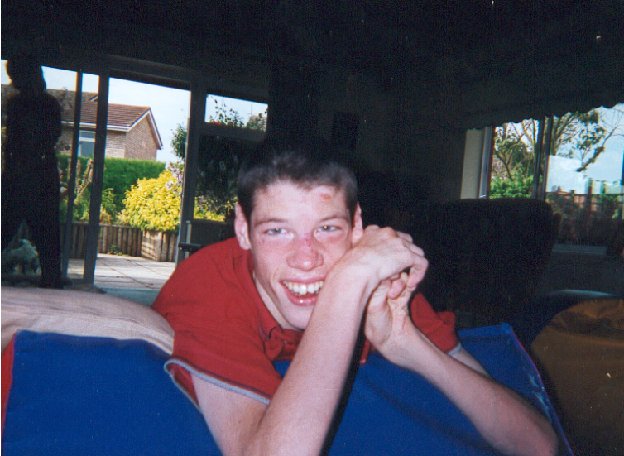
Tom (photo above) was a very sociable young man with profound and multiple learning disabilities, including complex health needs. Although he had no speech he had a great sense of humour and a whole range of ways that he communicated his keen interest in food, films, beer and blondes! He attended a residential special school. His parents were both teachers, his mother a teacher of pupils with profound and multiple learning disabilities. They knew the system and they did everything they could to get transition planning underway for Tom so there would be a good plan for when he left school. They were told not to worry, it was too early to start planning. But despite their best efforts, by the time Tom was approaching 19 no provision had been identified for him. The school kept him on for a bit longer, but eventually set a deadline for him to move on. His parents, and eventually a social worker, searched frantically for a residential placement for him but to no avail.

In the end, Tom spent 96 days in an NHS psychiatric assessment unit. His parents think that this was because there was nowhere else for him to go. Eventually a suitable placement did come up in the area and he was transferred to a suitable residential service. But during this time, when he was not in an environment where he was supported by people with the right skills, his health was deteriorating. Tom was eventually diagnosed with a number of serious conditions but it was too late for Tom and he died a short while after his 20th birthday.

Tom’s parents complained to social services about the lack of transition planning and the failure to plan for or commission new provision for him. Both complaints were upheld:
“I agree with the conclusion that both Tom and yourselves were entitled to expect accommodation would be available within a reasonable time to meet Tom’s needs and we have failed to deliver this” – Head of adult care services

However far Tom’s death may also be attributed to the care he received in the NHS (on which, see Tom’s story in Mencap’s 2007 report Death by indifference), the question Tom’s parents continue to ask is, “If good planning had been in place, and Tom had reached ‘safe hands’ sooner, would he still be alive today?”

“The totality of the experience of the family was akin to that of experiencing a storm. When it was all over, it was not only the winds that had died” – Tom’s father

Making it happen

Good transition planning for young people with profound and multiple learning disabilities (PMLD) includes:

- A holistic approach, covering all aspects of the support, including health and social care needs and not just education.

- Provides continuity so people don’t have to start all over again because information is not passed on.

- Good Person Centred Planning.

- An up to date communication passport to go with them through all transition points.

- A health action plan which includes all aspects of people’s complex health needs.

- A transition social worker to help the individual and their family move through to adults services.

- Maintenance of therapeutic support, no sudden reductions in access to speech therapy and physiotherapy for example.

Improving the Workforce

What we want

- A skilled and sustainable workforce.

- Staff who are trained to meet people’s complex health, communication and behaviour needs.

- Staff whose pay reflects the additional skills and training they need to provide good quality support.

Main response

All people with a learning disability need access to good support wherever they live, work or to access leisure opportunities. People with profound and multiple learning disabilities (PMLD) should not have their choices restricted because they cannot get the personal support that they need. Personal support staff need to have a full understanding of complex health needs, be able to communicate with people who may not use formal means of communication and sometimes to support people whose behaviour challenges services.

Communication training is available but not resourced or prioritised to be as effective as it might - Health professional

The PMLD Network are concerned that the lack of availability of a suitably skilled workforce and the fact that some local authorities refuse to pay for skilled staff support are major barriers to the inclusion for many people with PMLD.

Families are often very concerned about the skills and abilities of staff. They want highly skilled staff who can care for their son/daughter in the way that they would themselves.

High staff turnover in this area of service provision results in poor continuity of care and then the process of learning to support someone well may start all over again.

Making it happen

The workforce for people with profound and multiple learning disabilities needs:

- Induction training that includes information on the needs of children and adults with PMLD.

- Access to high quality training, in particular, communication skills training, complex health needs and supporting people with behaviour that challenges.

- Training that increases awareness of the attitudes and values that can lead to people making judgements about the quality of people’s lives.

- Training in determining the best interests of adults who lack the capacity to make a decision for themselves.

- Training in how to help people show their preferences and choices.

Making it Happen – the priorities

Including Everyone

Current situation | Situation in 3 years time if Valuing People has worked for people with PMLD | How we will get there
There is a lack of national and local data on the population of people with PMLD | There will be national and local data on the population of people with PMLD. | The DH will require local authorities to develop their SN Registers to identify people with PMLD and this data will be nationally collated.
There is poor monitoring of service provision for people with PMLD | There will be better monitoring of service provision for people with PMLD.  CSCI will be able to report on the quality of life of people with profound and multiple learning disabilities in its annual report on the ‘State of Social Care’ | CSCI will develop an inspection framework which includes quality of life indicators relevant to people with PMLD.
It is not clear that the true costs of good support are understood or that there is commitment to meet these costs | There will be recognition of the true costs of good support.  The DH will pilot a scheme to provide central government funding for people with high support needs. | ADASS will conduct research to identify the number of packages of support costing above £100,000 across the UK.

Personalisation

Current situation | Situation in 3 years time if Valuing People has worked for people with PMLD | How we will get there
Few people with PMLD are using individual budgets and direct payments | Individual budgets will include everyone. The true cost of the support needs of people with PMLD will be understood and met | Research into support packages.  Targets will be set for local authorities to offer people with PMLD an individual budget
Many people with PMLD don’t have a person centred plan (PCP). People with PMLD are often not meaningfully involved in developing their PCP. | People with PMLD will be given priority for person centred planning. Staff will be properly trained in meaningfully involving people with PMLD in the development of their person centred plans | Staff training in ways of engaging with people with PMLD and meaningfully involving them in the development of their PCP

What People Do During the Day (And Evening And Weekends)

Current situation | Situation in 3 years time if Valuing People has worked for people with PMLD | How we will get there
Day services programme is not planned, monitored and evaluated with the needs of people with PMLD in mind | Day services programme will be planned, monitored and evaluated with the needs of people with PMLD in mind | VPST will provide a toolkit about making activities meaningful to people with PMLD and about making sure services are equipped for meeting complex physical and health needs (including resource bases and Changing Places toilets)

Health

Current situation | Situation in 3 years time if Valuing People has worked for people with PMLD | How we will get there
Access to both mainstream health care and high quality specialist health care is poor | NHS Commissioning that recognises the need for access to specialist expertise. | Investment in the growth of local health specialists to meet the needs of the increasing numbers of people with complex health needs.
Many people with PMLD have undiagnosed health conditions | Annual health checks, Health Action plans and health facilitation in place for all people with profound and multiple learning disabilities (PMLD). | PCTs will commission these services.  The targets and outcomes will be performance managed by the Strategic health authorities.
Housing

Current situation | Situation in 3 years time if Valuing People has worked for people with PMLD | How we will get there
Many people with PMLD are left behind in traditional residential settings | People with PMLD will have choice and control about where they live | By providing a range of options from registered care to supported living.  More funding for high quality, safe and supported living opportunities.
Lack of skilled support means that many people with PMLD can not choose where they want to live | Support staff will be trained to meet complex needs so that lack of skilled support does not mean that people can not choose where they want to live | Support staff will be trained in supporting people with complex needs

Advocacy and Rights

Current situation | Situation in 3 years time if Valuing People has worked for people with PMLD | How we will get there
Many people with PMLD do not have access to an appropriately skilled advocate | Greater advocacy provision for people with PMLD | The needs of people with PMLD will be pushed up the agenda and increased funding for advocacy in particular non-instructed advocacy will be available. More advocates will be trained in non-formal communication techniques which will enable them to be able to practise as non-instructed advocates.
Very few self-advocacy groups and groups involved in policy-making are representative of people with PMLD | Every self-advocacy group and groups involved in policy-making will be inclusive of people with PMLD | There will be a PMLD champion in the organisation and the organisation will have a policy on how they creatively consult with people with PMLD

Partnership with Families

Current situation | Situation in 3 years time if Valuing People has worked for people with PMLD | How we will get there
Many families reach Breaking Point because they do not get the support they need | Families will be getting the support they need, including a minimum entitlement to good quality short breaks | A duty on local authorities to provide short breaks to support families of adults with PMLD

People as Local Citizens

Current situation | Situation in 3 years time if Valuing People has worked for people with PMLD | How we will get there
People with PMLD are not valued citizens | Barriers to community inclusion will have been removed | There will be specialist and flexible transport, Changing Places toilets in all big public places and good manual handling policies and practices

Making The Transition to Adulthood A Positive Experience

Current situation | Situation in 3 years time if Valuing People has worked for people with PMLD | How we will get there
There is poor transition planning for young people with PMLD and it is often not inclusive of their social and health needs | A holistic approach to transition planning, covering all aspects of support, including the person’s health and social care needs and not just their education | Good person centred planning, an up to date communication passport, a health action plan, maintenance of therapeutic support, a transition social worker to help the individual and their family move through to adult services

Improving The Workforce

Current situation | Situation in 3 years time if Valuing People has worked for people with PMLD | How we will get there
Many personal care staff do not know how to support people with PMLD | A skilled and sustainable workforce who are trained to meet people’s complex health, communication and behaviour needs | Staff training in:  - communication skills  - complex health needs  - supporting people with behaviour that challenges  - understanding what it means to have PMLD  - how to make best interests decisions  - how to help people with PMLD show their preferences and choices.  Staff pay to reflect the additional skills and training they need to provide good quality support.

For more information, please contact Beverley Dawkins, Chair of the PMLD Network on 020 7696 5558 or email beverley.dawkins@mencap.org.uk

Appendix 1

The PMLD Network consists of the following organisations:

BILD
Circles Network
Foundation for People with Learning Disabilities
Mencap
North West Training and Development Team
Rett Syndrome Association UK
Scope
See Ability
Sense
The Challenging Behaviour Foundation
The Children’s Trust
The Ridgeway Partnership NHS Trust
Westminster Learning Disability Partnership
Parent representatives

Appendix 2

Understanding profound and multiple learning disabilities

Learning needs. Like all of us, people with profound learning disability will continue to learn throughout their lives if offered appropriate opportunities. Such opportunities must take account of the fact that most people are likely to be learning skills that generally appear at a very early stage of development. For example, cause and effect, such as pressing a switch to make something happen, or turn-taking, such as rolling a ball between two people. Learning is also likely to take place very slowly. For example, some people may have a very small short-term memory and so will need the opportunity to encounter events many times before they become familiar. Constant repetition and a great deal of support will be needed to generalise learning into new situations. Supporting the learning needs of a child or adult with profound and multiple learning disabilities also needs to take account of any additional needs, such as sensory needs (see sensory needs section), so that the best approach to learning can be established.

Communication needs. Many people with profound and multiple learning disabilities rely on facial expressions, vocal sounds, body language and behaviour to communicate. Some people may use a small range of formal communication, such as speech, symbols or signs. However, some people with profound and multiple learning disabilities may not have reached the stage of using intentional communication, and they may rely on others to interpret their reactions to events and people. Most people are also likely to find it difficult to understand the verbal communication of others. Some people will rely heavily on the context in which the communication takes place, such as the clues given by a routine event. It is important that those who support people with profound and multiple learning disabilities spend time getting to know their means of communication and finding effective ways to interact with them.

Physical needs. Some people described as having profound and multiple learning disabilities are fully mobile. Many may use a wheelchair. Others have difficulty with movement and are unable to control or vary their posture efficiently. These individuals will need specialised equipment to aid their mobility, to support their posture and to protect and restore their body shape, muscle tone and quality of life. It is vital that people with physical needs have access to physiotherapy, occupational therapy and hydrotherapy, and that their carers receive training to enable them to manage their physical needs confidently on a day-to-day basis.

Complex health needs. There is a wide range of conditions that children and adults with profound and multiple learning disabilities may have, such as complex epilepsy. An increasing number of people are described as being ‘technology dependent’, which may mean they need oxygen, tube feeding or suctioning equipment. Some people have conditions that are described as ‘life-limiting’. Others have fragile health and may be susceptible to conditions like chest infections and gastro-intestinal conditions. Skilled support may be needed for feeding and swallowing, as good nutrition is a vital part of achieving good health. Many people may experience a combination of medical needs and need access to specialised health support to ensure the holistic management of
these conditions.

People with profound and multiple learning disabilities experience the same health conditions as the rest of the population. The challenge is about how these conditions are identified in people who may not be able to communicate their symptoms easily. For example, it is very important to develop effective ways to recognise and manage pain. It is crucial that a proactive approach is taken to ensure that each person is able to achieve the best possible health they can, for example, by arranging annual health checks and support to access general health care.

Sensory needs. Special attention needs to be given to the sensory needs of people with profound and multiple learning disabilities. Many people have some degree of visual and or hearing disability or a combination of both. Some people’s sense of taste or smell may be affected by the drugs they are prescribed. Other people may be hypersensitive to touch. It is essential to know as much as possible about a person’s vision, hearing and other senses in order to develop the most effective way to approach their learning and communication needs.

Understanding behaviour. Some behaviour that is seen as challenging may arise because little attention has been given to other needs. It should never be assumed that certain behaviours are just part and parcel of having profound and multiple learning disabilities. For example, a behaviour that services may see as challenging, such as pushing people, may be an attempt to communicate a need. Other changes in behaviour may be due to undetected health needs, such as scratching the face because of a toothache. However, some behaviour will be because people are simply doing things that they enjoy, for example putting a hand under the tap to enjoy the feeling of running water. The important thing is to understand what the behaviour may mean and to respond accordingly, such as checking out any possible health causes or making changes in the environment.

Mental health needs. The mental health needs of individuals with profound and multiple learning disabilities are often not considered. For example, someone who becomes very quiet and passive may be seen as having improved their behaviour when in fact they are depressed. Research suggests that people with profound and multiple learning disabilities may be more susceptible to mental health conditions than the rest of the population. It is important that careful attention is given to these needs and that the right treatment and support is found to meet them.

Profound and multiple learning disabilities and other syndromes or conditions. There are many other conditions and syndromes used to describe people, some of whom could also be described as having profound and multiple learning disabilities. Conditions and syndromes that are more usually associated with profound and multiple learning disabilities include Rett syndrome, Tuberous Sclerosis, Batten’s Disease and some other rare disorders. However, some people who are described as having autism and Down’s syndrome may also have the combination of profound learning disability and one or more of the needs we have discussed – therefore, they could equally be described as having profound and multiple learning disabilities.

Support needs. All children and adults with profound and multiple learning disabilities will need high levels of support from families, carers and paid supporters. This will include help with all aspects of personal care, such as washing, dressing and eating, as well as ensuring that each individual has access to high quality and meaningful activity throughout their lives. Those who offer this support will need access to good quality and appropriate training, especially around particular skills. For example, on particular feeding needs and communication approaches. Good support is person-centred, flexible and creative to enable the person with profound and multiple learning disabilities to learn and to achieve their full potential.

Membership of the PMLD Network is listed in Appendix 1
Valuing people with profound and multiple learning disabilities’ Mencap 2001
‘Valuing People: A New Strategy for the 21st Century’ DOH 2001
Fyson, R and Ward, L (2004) ‘Making Valuing People work: Strategies for change in services for people with learning disabilities’.
Mapping and service needs for those with ASD or PMLD, Research for Tomorrow, Today (2003)
Carpenter, B: ‘Sustaining the family. Meeting the needs of families of children with disabilities’ BJSE, September 2000
Kirk, S and C. Glendinning (2004) ‘Developing services to support parents caring for a technology-dependent child at home’ in. Child: Care, Health & Development 30 , 3, 209–218.
Sheffield Care Trust (2006) – summary of findings from Adult Learning Disability Day Services PMLD sub group and additional Case Register
Advocating for Equality’, IAC (2004)

